Assignments-2

[1] Design 4-bit Ripple Carry Adder with the help of 1-bit adder.

Program :-

Output :-



[2] Design D-flipflop and reuse it to implement 4- bit Johnson Counter.

Program :-

Output :-

[3] Reuse 2:1 Mux code to implement 8:1 Mux.

Program :-

Output :-

[4] Design a Full Subtractor with Gate Level Modeling Style.(use primitive gates)

Program:-

Output :-

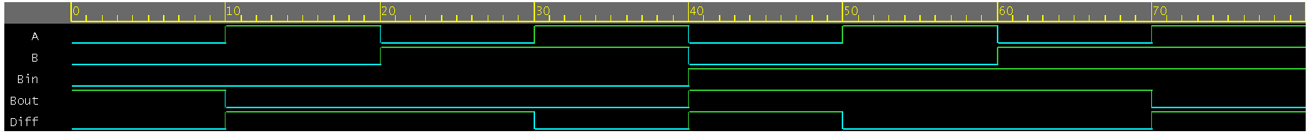

[5] Design a 2X4 decoder using gate level modelling.

Program :-

Output :-

[6] Design a 4x1 mux using operators. (use data flow)

Program :-

Output :-



[7] Design a Full adder using half adder.

Program :-

Output :-

